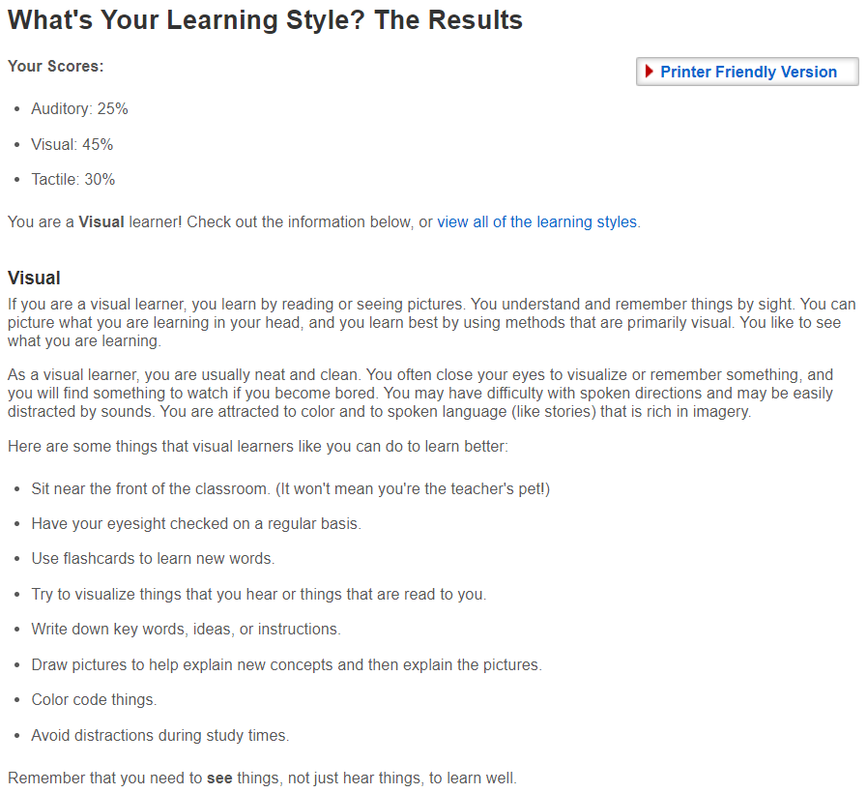

The results of my Learning Style quiz didn’t really surprise me, though the scores of auditory and tactile learning were closer than I expected. In order to optimize my learning in this class, I will try to keep organized, detailed notes on concepts and processes on how to do things, and if I need help, I will most likely try to find a video online with someone who has already figured it out. I think that the best thing you can do to help me succeed is to continue doing what you’re doing: posting videos at the beginning of the week that walks through the lesson with everyone and being available for questions and advice.